PROJECT SPECIFICATIONS

INTRODUCTION:

This is a fullstack application with Node backend and React frontend. It is a website for a business that provides breakup service. The owners of the business (Mai and Daria) are also the persons who will directly carry out the breakup task per request.

Business name: THE BREAKUP.

The dot at the end of the name represents the ending of relationship.

Problem to solve: We provide effective and customized communication for breakup. We minimize ghosting, yelling, or blaming each other.

Target audience: Millenials

Specific goals: Within 3 months of launching we would like to have at least 10 clients (lead users). We will follow up on these clients (with their consent) about their experience with our service and improve it accordingly. We also would like to ask clients to provide testimonials if they feel comfortable.

MARKET RESEARCH:

There is no competition on the market at the moment. We are the first one to provide this service.

Millennials are outsourcing many of the traditionally personal tasks to other people, for example personal dating coach or personal shopper. It is expected that they would be willing to let us to handle their inconvenience in breaking up at an affordable price.

BUSINESS MODEL:

Revenues: Our price structure allow clients to choose between an email service (10 euro) or a phone call service (30 euro).

Costs of business: We create and maintain the business website by ourselves, so it is free. We will have to pay for domain, hosting, phone contract, and Paypal transaction fee.

Below is the printscreen from our Paypal test account. We opted for a third party payment handler so clients are more confidence in buying the service. As a new company, we understand that clients can be reluctant to let us handle their bank information. For the email service, we charge 10 euro and receive 9.31 euro. For the phone service, we charge 30 euro and receive 28.63 euro.

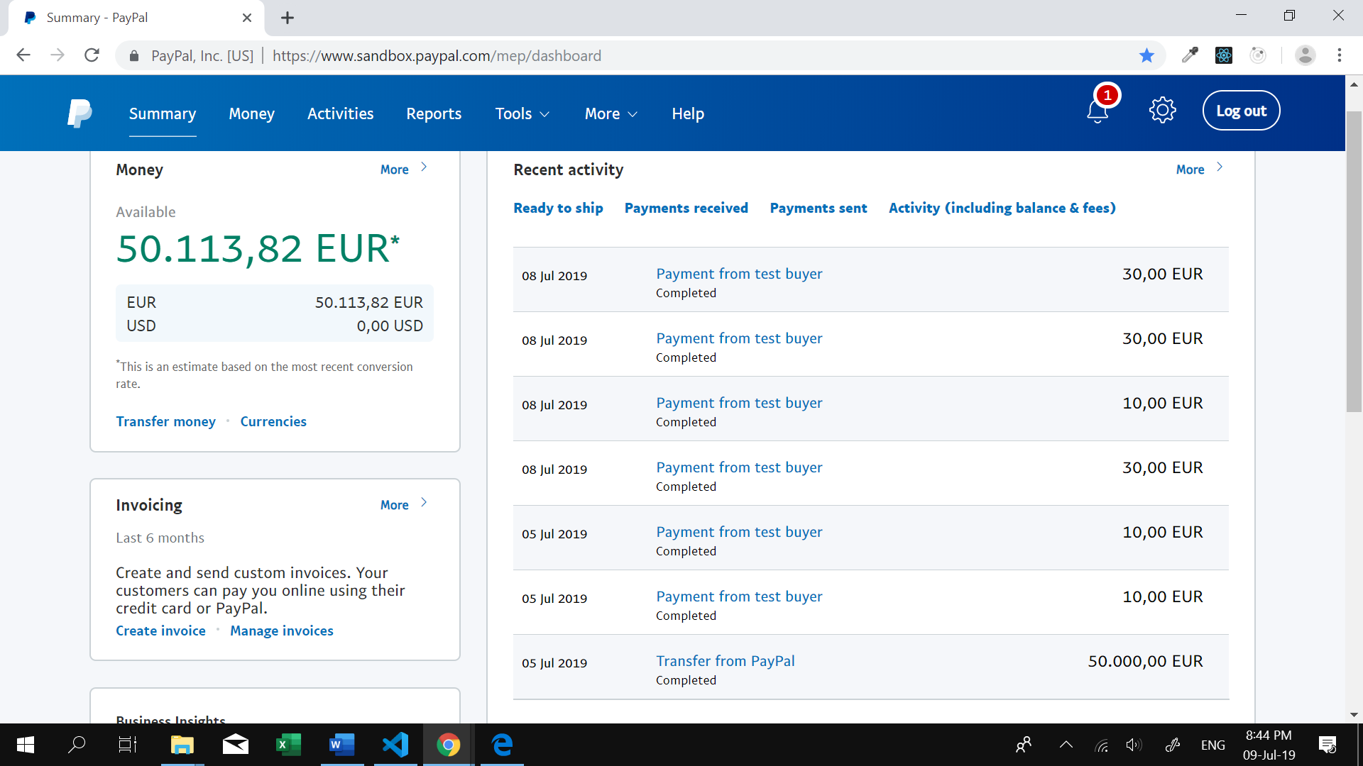

TECHNICAL SPECIFICATIONS:

Below is the representation of our sitemap:

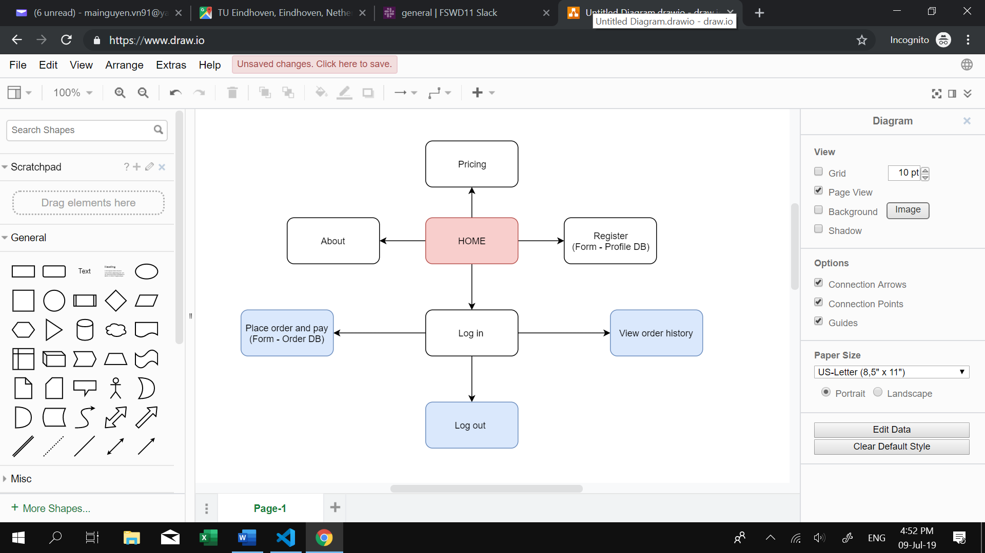

- Before logging in, visitors to out website can see About (introduction to our business), Pricing (our price scheme and description of service), and Register.

- By registering on the website, the information of the users is stored in our database under a table named “Profile”. This table contains the number of the user (ID), name, email address, and hashed password.

- After logging in with email and password, users can place their order via a form. The information of the others is stored in our database under a table named “Order”. This table is related to the “Profile” table via user ID number.

- After submitting the order, users is taken to the payment website by Paypal. Upon successful payment, they can see the order confirmation page. Logged in users can also see a list of all their orders in the history.

The “Order” table contains necessary information for us to perform the service. By default, the status of the order after payment is “being process”. Once the order has been executed, the admin can change the status to “completed” by running an update table query on SQL. This updated status is visible to the users of that acccount.